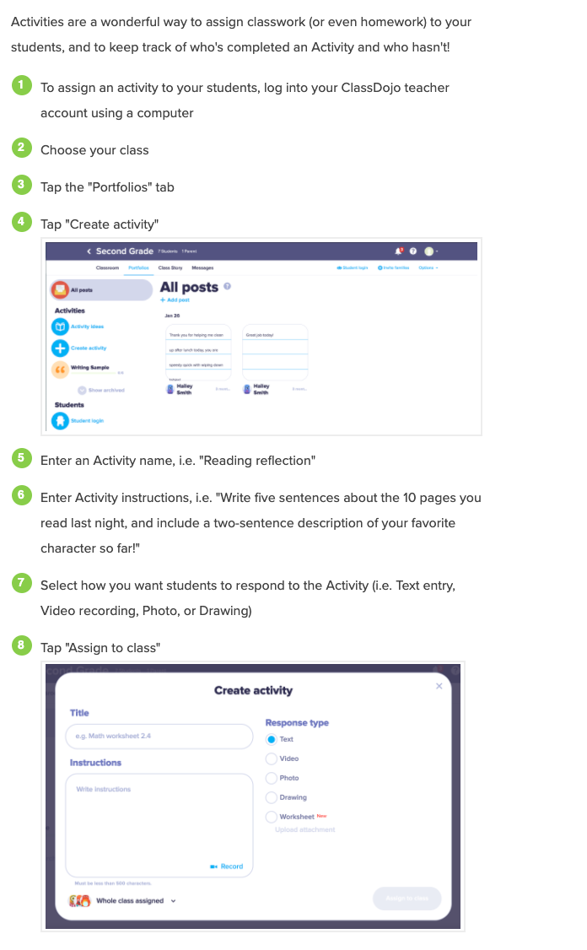
Teacher Directions- Assign Activity On Class Dojo

